# BASE – Ethereum Layer 2 Solution built by Coinbase

— Base is a **Layer-2 scaling solution** for Ethereum built by Coinbase which aims to make transactions faster while leveraging the security of the Ethereum mainnet.  
  
— The network achieves its primary goals of increased speed and reduced cost, though critics say the network is too centralized.  
  
— Coinbase’s end vision is for Base to become a foundational part of an eventual “Superchain” of fully decentralized and interoperable Ethereum Layer 2 networks.

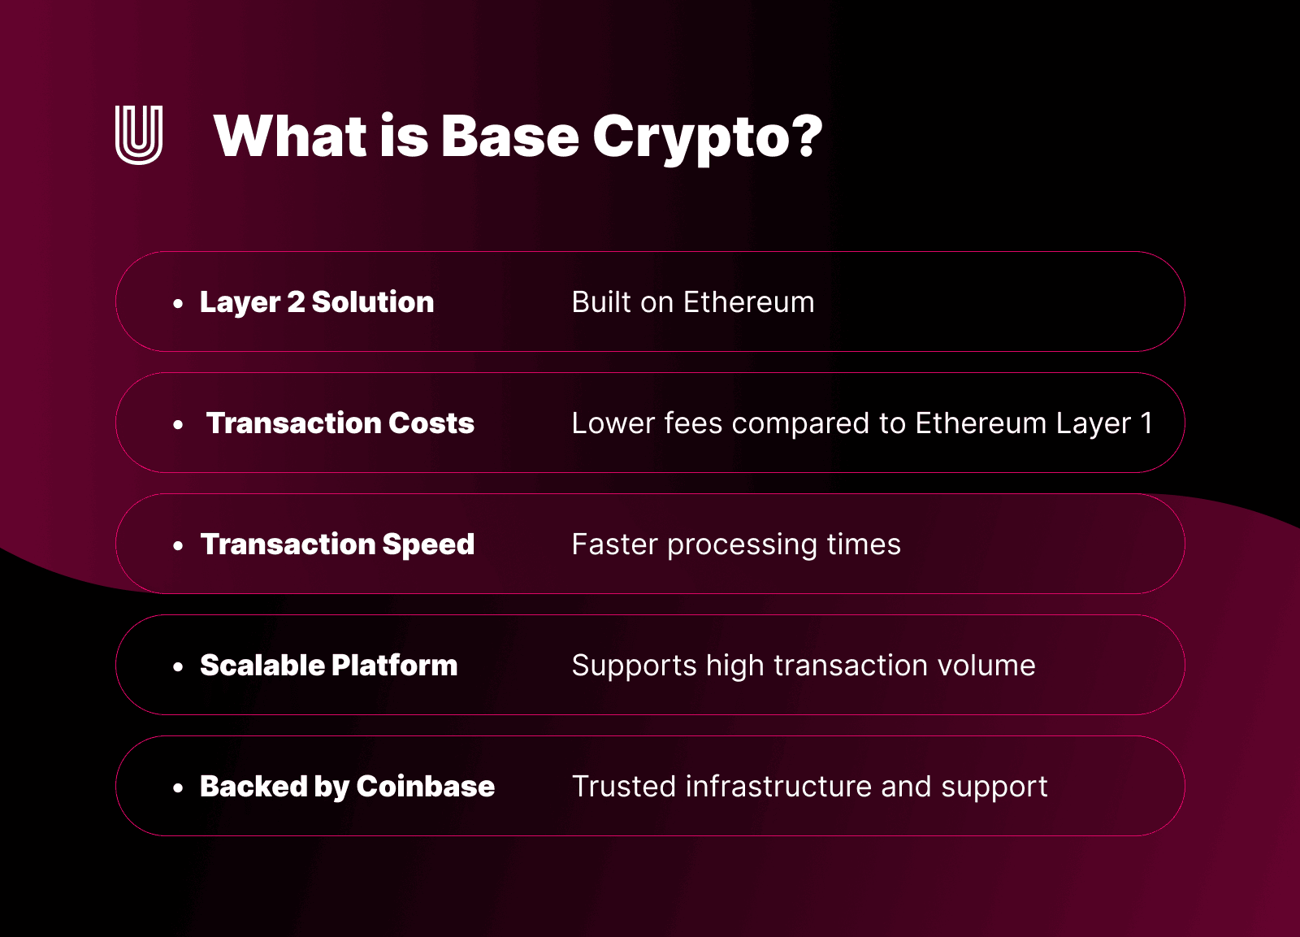

## How it works

The Base network, Coinbase’s [Layer-2](https://www.ledger.com/th/academy/layer-2-blockchains-explained) Base blockchain was built to unleash Ethereum’s full potential by **offloading transactions** from the **congested mainnet**.

IT employs Optimistic Rollups to aggregate and process transactions off-chain before submitting them to the Ethereum mainnet for finalization. This process significantly reduces the computational burden on Ethereum, enabling faster and more cost-effective transactions.

Unlike [Ethereum](https://www.ledger.com/th/academy/what-is-ethereum), where blocks fill up and gas fees spike during peak demand, Ethereum Base vs. Ethereum shows **dramatically faster, cheaper transactions** on Base, thanks to its **optimized rollup architecture**.

By routing **smart-contract calls through Base**, developers tap a scalable, high-throughput environment while still benefiting from Ethereum’s security.

The architecture of Base ensures that their security and validity remain uncompromised while transactions occur off-chain

[Smart contracts](https://www.ulam.io/blog/smart-contract-definition-use-cases) on the Ethereum mainnet validate the rollups, ensuring that all transactions processed by Base adhere to Ethereum’s decentralized consensus.

Base is fully compatible with the Ethereum Virtual Machine (EVM), meaning developers can deploy their existing Ethereum-based decentralized applications (dApps) on Base with minimal changes. This compatibility ensures interoperability with Ethereum’s extensive ecosystem, including tools, libraries, and wallets.

By offloading transaction processing to Base, developers, and users benefit from drastically reduced gas fees while maintaining access to Ethereum’s robust infrastructure.

This combination of scalability, cost-efficiency, and security positions Base as a powerful solution for developers seeking to create high-performance blockchain applications

## Comparison with other Layer 2 solutions

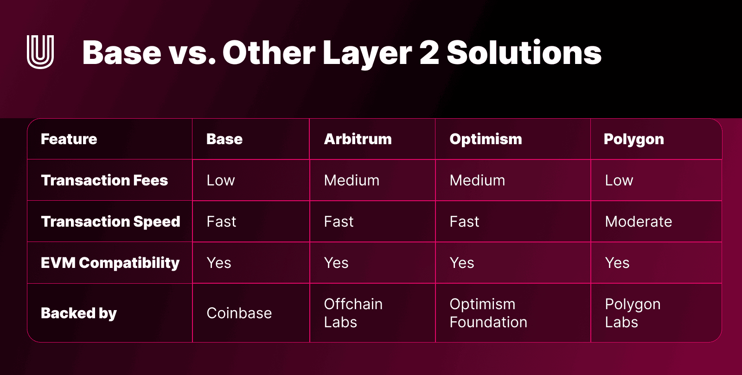

**Disadvantages of Ethereum**

Ethereum has powered web3 since its inception be it DeFi, NFTs, Tokens, or DAOs. But persistent scalability bottlenecks have been a hurdle for its growth: slow confirmations and exorbitant gas fees frustrate users and deter newcomers.

**Advantages of Base:**

 Base provides the low-fee, high-speed infrastructure necessary for mass adoption, making the path for dApps and transactions smoother.

## Understanding Coinbase L2 Base Network

* Developed by crypto exchange **Coinbase**, world’s leading cryptocurrency exchange
* Base is an Ethereum Layer-2 (L2) blockchain designed to make Ethereum more accessible while retaining the **security of the main chain**.
* Layer 2 blockchains are scaling solutions that help carry the traffic load for their parent blockchains
* Base enables faster transaction processing, and, notably, the L2 claims to have **transaction fees that are ten times cheaper than Ethereum**, based on a 90-day average.
* Base markets itself as “developer-friendly” and is fully compatible with the [Ethereum Virtual Machine](https://www.ledger.com/academy/topics/crypto/understanding-ethereum-virtual-machine-evm) (EVM).
* developers don’t need to make major tweaks in their code and tools to deploy their applications on Base – due to **EVM compatibility**
* fast and cheap transactions, interoperability and smart contract support make it capable of supporting countless blockchain apps and services.
* users can also easily **move assets** between Ethereum, Coinbase, other EVM-compatible chains, and the Base network.
* On the Base network, you can access **decentralized exchanges** and **DeFi platforms**, **manage Ethereum tokens and NFTs**
* built using [**OP stack**](https://optimism.mirror.xyz/fLk5UGjZDiXFuvQh6R_HscMQuuY9ABYNF7PI76-qJYs)and operates as an Ethereum Layer 2, many of the top Ethereum platforms and services now use the Base network, including Aave, Chainlink, Etherscan, and Sushi Swap.

## How does Base Network work?

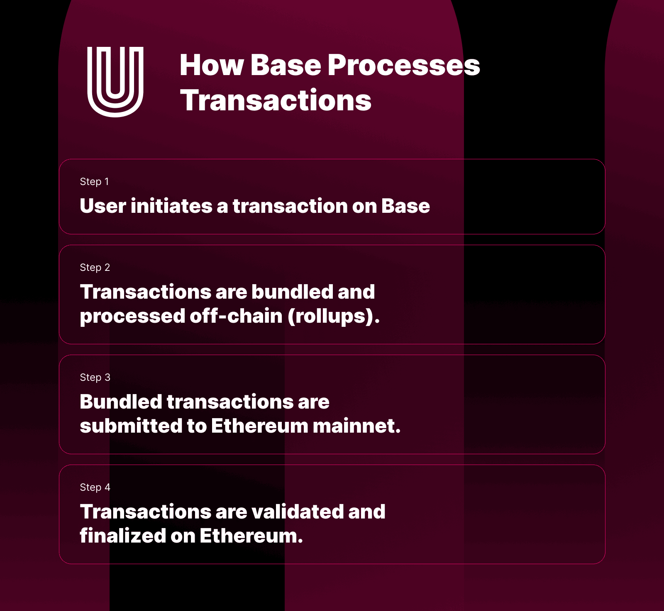

* Base is specifically a [Blockchain Rollup L2](https://www.ledger.com/th/academy/what-are-blockchain-rollups).
* Base works by rolling up many Ethereum transactions off-chain and sending them back to the main chain in a single block.
* Base then submits a summary of the transactions – which includes cryptographic proof that indicates the validity of the off-chain transactions – to the Ethereum mainnet.
* built with Optimism’s existing OP stack infrastructure.

## OP Stack- Optimism’s scalability architecture

The OP Stack is also a bet that the future is neither multi-chain nor mono-chain.

Instead, we believe that a group of highly integrated chains will form an emergent structure, the **Superchain**, which powers the collective.

* Released in October 2022, the OP Stack is a collaborative effort from OP Labs and The Optimism Collective.
* development teams behind the Optimism Network – a popular Ethereum L2 – and the DAO that currently oversees it.
* OP stack provides the necessary components to build a fully functional layer-2 blockchain.
* key features of the OP stack is that each of these components can be easily replaced and upgraded. This makes networks built on OP Stack highly adaptable.

## What is the Optimism Superchain?

* The **Optimism Superchain** is a vision for a network of interconnected Ethereum Layer 2 chains, each with its own ecosystem.
* Using the same OP stack infrastructure makes these chains interoperable.
* Much like the [Cosmos SDK](https://www.ledger.com/th/academy/cosmos-the-future-of-blockchain-interoperability) for IBC blockchains, the Optimism Superchain would allow these networks to share governance and bridging protocols.

## Does Base Support NFTs?

* Base network supports NFTs and is fully integrated with the major **NFT marketplace, Opensea**
* the “Onchain Summer” event that launched Base reportedly saw over 700,000 NFTs minted. The event included NFT collections from prominent brands like Coca-Cola and Atari, as well as web3-native names like Friends With Benefits and Coinbase itself.
* **other major L2s like Polygon, Immutable X, and Arbitrum**, Base can drastically reduce the fees associated with trading NFTs
* All users have to do is transfer ETH to Base using [The Base Bridge](https://docs.base.org/tools/bridges/) to be able to purchase Base NFTs.
* it’s possible to both mint NFTs on Base, and even develop custom NFT gallery apps using third-party platforms.
* Most popular Base NFT collections today include the
  + collectible NFT card game Parallel Alpha,
  + generative NFT collection NFToshis,
  + innovative community art collection BasePaint.

## Advantages of Base Blockchain

1.Low fees:

Like most L2 networks, Base enables users to execute Ethereum transactions at a fraction of the cost. With every Base transaction, you incur two costs:

**a fee to execute the transaction on the L2 network and a fee to publish the transaction on Ethereum (L1) as part of a block.**

Naturally, the Ethereum mainnet gas fee is usually higher than the Layer 2 gas fee, though both fees are dynamic and increase during periods of heavy usage

**2. Developer-friendly:**

* developers can effortlessly deploy their existing codebase on the L2 network without drastic modifications.
* Base makes it easy for blockchain apps to integrate fiat on-ramps while benefiting from access to Coinbase’s user base and $130 billion in assets.

3. Scalable Web3:

* Thanks to its Optimistic rollup functionality, Base helps solve Ethereum’s scaling issues by moving the bulk of the transaction process off-chain.
* Using Base is a way to keep transaction costs down while benefiting from the security, transparency, and interoperability of the Ethereum network.

## How to Access Base Network from a Ledger

To access the Base Network from a Ledger device, your device should have an Ethereum app installed. If you already have an Ethereum app, use the following steps to create a Base account:

1. Navigate to “Accounts” on the menu in the left sidebar and select “Add account.”
2. From the dropdown menu, select Base “(ETH)” and click on “Continue.”
3. Connect your Ledger device to Ledger Live and unlock it.
4. Launch the Ethereum app on your Ledger device and click “Add account” to access the Base network.

If you want a step-by-step guide to this entire process, you can visit the Ledger [support page](https://support.ledger.com/hc/en-us/articles/13334147998877-BASE?docs=true).

You can also send ETH, Ethereum NFTs, and other ERC-20 tokens to your Base account. It’s important to note that NFTs on Base are not displayed in Ledger Live, although you can view Base NFTs in the “Discover” section of the Zerion app.

Centralization**:**

Coinbase is solely in charge of operating the Base network’s sequencer.

**Sequencer** is a specialized node that is vital for creating an ordered list of transactions.

Base’s roadmap, which outlines the network’s many plans for further decentralization, including splitting up control of its smart contract upgradability through a layered, Multisig structure.

Coinbase does not have the power to modify or reverse transactions on Base.

## Security

Base is working alongside the Optimism collective to develop Pessimism, a monitoring stack that will improve the security of the OP stack, including its bridges and infrastructure.

## Does Base have a native Token?

* No
* native tokens can have many important functions, most notably relating to the governance of a blockchain and as a reward for network validator nodes
* as the blockchain becomes more decentralized, a native governance token could be useful for validators to earn rewards.

## How to Send Crypto to a Base account on Ledger

Here’s how to send Base (ETH) using[Ledger Live](https://www.ledger.com/th/ledger-live):

1. Navigate to the “Accounts” section in the left sidebar menu, select “Base (ETH)” and hit “Send.”
2. Input the recipient’s address, carefully double-check it (even a small error in the address could lead to loss of funds), and click “Continue.”
3. Specify the amount you wish to send. You could try sending a small amount first to ensure the crypto was received before doing a large transaction.
4. Review the transaction summary, including the amount and network fees, and click “Continue.”
5. On your Ledger device, confirm and approve the transaction by pressing both buttons simultaneously. Your Ledger hardware wallet balance will be updated once the blockchain confirms the transaction.

## Top Uecases of Base L2 Network

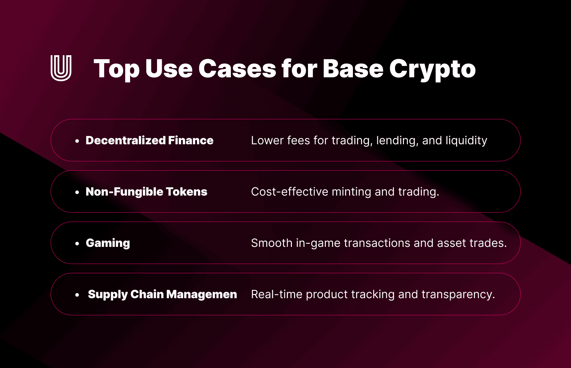

## Real-World Examples

• **SushiSwap**: This DEX integrated Base to deliver faster transactions with minimal fees, improving the user experience for token swaps.

• **Uniswap**: Uniswap uses Base to handle transactions more efficiently, ensuring traders experience reduced costs and delays.

• **OpenSea**: By adopting Base, OpenSea reduces the cost of creating and trading NFTs, making it more accessible to users.

• **Aave**: As a leading liquidity protocol, Aave leverages Base to make lending and borrowing more affordable and efficient.

## Roadmap and Upcoming Developments

Base’s development roadmap includes key upgrades that aim to enhance its functionality and ecosystem:

• **Advanced Rollup Technology**: Future updates may incorporate zero-knowledge (ZK) rollups or hybrid models to further optimize scalability and security.

• **Interoperability Features**: Expanding support for cross-chain communication will allow Base to integrate seamlessly with other blockchains, fostering a more connected ecosystem.

• **Enhanced Developer Tools**: Base plans to introduce additional resources for developers, such as advanced analytics, improved SDKs, and new APIs to simplify dApp creation.

## For Users- How to connect to Base L2

1. **Access the Network**:

To begin using Base, users must first connect their wallet. Popular wallets like [Coinbase Wallet](https://www.coinbase.com/wallet) and [MetaMask](https://metamask.io/) are fully compatible with the Base network.

2. **Transfer Funds**:

Transfer assets from Ethereum or other compatible chains to Base via bridging solutions. The process is straightforward, with guides available through platforms like [Base Bridge](https://bridge.base.org/).

3. **Explore dApps**:

Once connected, users can access a variety of decentralized applications built on Base. These range from DeFi platforms like [Uniswap](https://uniswap.org/) and [Aave](https://aave.com/" \t "_blank) to NFT marketplaces such as [OpenSea](https://opensea.io/blog/" \t "_blank).

4. **Low-Cost Transactions**:

Enjoy reduced gas fees and faster transaction speeds compared to Ethereum Layer 1. This makes interacting with Base’s ecosystem more affordable and efficient.

## For Developers- How to use Base L2 Network

1. **Start Building**:

Developers can use Base’s EVM-compatible infrastructure to deploy [smart contracts and dApps](https://www.ulam.io/blog/smart-contract-platforms) with ease. Tools like [Hardhat](https://hardhat.org/) and [Remix](https://remix.ethereum.org/) are fully supported.

2. **Use Base Testnet**:

Before deploying to the mainnet, developers can test their applications on the Base testnet. This allows for experimentation and debugging without incurring real-world costs. More information on accessing the testnet can be found in Base’s [developer documentation](https://base.org/).

3. **Grants and Incentives**:

Base offers developer grants to encourage innovation. These programs provide funding and support for projects that align with the network’s goals. Developers can apply through Coinbase’s dedicated portal for ecosystem initiatives.

4. **Integration with Coinbase Tools**:

Utilize Coinbase’s APIs, such as [Coinbase Commerce](https://commerce.coinbase.com/) and [Coinbase Wallet SDK](https://www.coinbase.com/wallet/developers), to enhance your dApp’s user experience and onboard new users easily.

## Resources for Getting Started

• [Base Bridge](https://bridge.base.org/): A tool for transferring assets to Base.

• [Base Developer Portal](https://base.org/): Comprehensive documentation and resources for developers.

• [Official Coinbase Blog](https://blog.coinbase.com/): Updates and announcements about Base and its ecosystem.

By providing intuitive onboarding for users and robust tools for developers, Base ensures a smooth entry point into its network for all participants. Whether you’re exploring or building, Base simplifies the process while offering the benefits of scalability and cost efficiency.

